**Architect and Build an End-to-End AWS Web Application from Scratch**

* Create Amplify to host the web application.
* Click on get started.

* Select deploy without provide and click continue.

* Write the app name.
* Click on choose file.

* Open the folder where you have put the index.html file.
* Create a zip file of index.html and then select that folder.

* It is successfully deployed.

* Now go to lambda function.
* Create a lambda function.
* Write function name.
* Select runtime environment.
* Click on create function.

* Click on code section below.
* Edit the code.
* Copy the code from the resources section lambda.txt file.

* Click on the test configuration and create a test event.
* Name the test event.
* Edit Event JSON and write as below picture.
* Then click on Save.

* Navigate to API Gateway.
* Create API Gateway, select REST API and click build.

* Create API name.

* Create method.
* Select POST method.
* Select the lambda function name.

* Click Create.

* Click on POST method and create a CORS.

* Now Invoke URL is created.

* Now Go to DynamoDB.
* Create DynamoDB Table.
* Click on create table.

* Write table name.
* Write partion key.
* Table is Created.

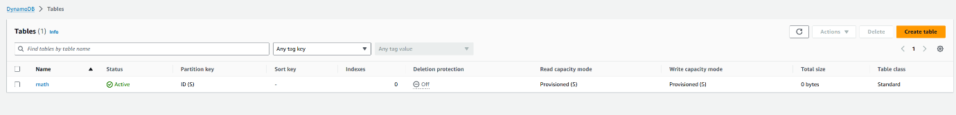

* Navigate to API Gateway.
* Click on configuration.
* Click on permissions.
* Then click on role name.

* Now you are in the IAM console.
* Now edit the Add Permission tab.
* Click on permission and edit inline policy.
* Select the JSON and edit it.

* Copy the code from the JSON.txt file and write the ARN of the dynambodb table in resource section in JSON file.
* Give the name to the policy.
* Then create the policy.

* Now navigate to lambda function.
* Go to the code source.
* Write the dynamodb table name.
* Click on save.
* Now click on deploy.
* Then Click on the Test. {we are testing the lambda function }
* Then the result will be shown and 200 status code. Will be displayed.

* Now navigate to API Gateway.
* We will be testing the API Gateway.
* Click on the POST method as shown Below.
* Click on Test.
* Then edit the request body as shown below.
* You can pass any value in ‘base’ and ‘exponent’.
* Click on Test.
* You will see the result status code 200 .

* After successfully status check the DynamoDB Table.
* You can see the result is added into the table.

* Now we need to edit the index.html file provided.
* As shown below screenshot write the Invoke URL that is generated when we create the API Gateway.
* Copy the invoke URL and replace in the ‘fetch’ line your copied URL API Gateway.

* Now save the index.html file.
* Now create a index.html to Zip file.
* Now navigate to Amplify and add the updated index.html file.
* We have linked the app in amplify with API Gateway.
* Now copy the link in the browser.

* In the browser write the value in base and power and click on calculate.
* Successfully with the answer will pop up.
* Now the result is updated into the DynamoDB table.
* The result is update in the DynamoDB table.

Successfully we have created end to end application.

